**PROJECT DOCUMENTATION**

***INSIGHTSTREAM: NAVIGATE THE NEWS LANDSCAPE***

***TITLE: NAVIGATE THE NEWS LANDSCAPE***

***TEAM ID :NM2025TMID37135***

***TEAM LEADER : PRIYADHARSHINI D***

***TEAM MEMBER : MAYHAK AISHETHA R***

***TEAM MEMBER: SOUNDARYA S V***

***TEAM MEMBER: MUBASSHIRA FATHIMA M***

***INTRODUCTION:***

***Navigating the news landscape is critically evaluating a fragmented and rapidly changing media environment to find trustworthy information amidst a surge of misinformation and diverse, often niche, sources. It involves using media literacy to assess credibility, understanding the impact of digital transformation on journalism and business models, and employing strategies to manage information overload to form accurate beliefs.***

***Navigating the global news landscape involves understanding its complex, ever-changing nature, marked by the digital revolution's impact on news distribution and consumption, the rise of new technologies and platforms, and challenges like misinformation and maintaining journalistic standards. Success requires adaptability from journalists and news organizations, alongside critical media literacy skills for consumers to effectively evaluate information and engage in informed discourse.***

***We focus on making news navigation simpler, reliable and user -friendly, helping people find accurate updates without confusion.***

***SOURCE CODE:***

***import React from 'react'***

***import '../styles/Footer.css'***

***import { useNavigate } from 'react-router-dom';***

***const Footer = () => {***

***const navigate = useNavigate();***

***return (***

***<footer>***

***<div className='footer'>***

***<ul>***

***<li onClick={()=> navigate("/category/")} >General</li>***

***<li onClick={()=> navigate("/category/Technology")} >Technology</li>***

***<li onClick={()=> navigate("/category/Science")} >Science</li>***

***</ul>***

***<ul>***

***<li onClick={()=> navigate("/category/Lifestyle")} >Lifestyle</li>***

***<li onClick={()=> navigate("/category/Health")} >Health</li>***

***<li onClick={()=> navigate("/category/Fitness")} >Fitness</li>***

***</ul>***

***<ul>***

***<li onClick={()=> navigate("/category/Business")} >Business</li>***

***<li onClick={()=> navigate("/category/Stock Markets")} >Stock Markets</li>***

***<li onClick={()=> navigate("/category/Exchanges")} >Exchanges</li>***

***</ul>***

***<ul>***

***<li onClick={()=> navigate("/category/Geo-Politics")} >Geo-Politics</li>***

***<li onClick={()=> navigate("/category/Wars")} >Wars</li>***

***<li onClick={()=> navigate("/category/Current-Affairs")} >Current Affairs</li>***

***</ul>***

***</div>***

***<hr />***

***<p>SB news - &copy; 2023 - All rights reserved</p>***

***</footer>***

***)***

***}***

***export default Footer***

***CODE:***

***import React, { useEffect, useState } from 'react'***

***import '../styles/Hero.css'***

***import axios from 'axios';***

***import { Link, useNavigate } from 'react-router-dom';***

***import { GeneralContext } from '../context/GeneralContext';***

***import Spinner from 'react-bootstrap/Spinner';***

***const Hero = () => {***

***const {topNews} = React.useContext(GeneralContext)***

***return (***

***<>***

***{topNews.length > 0 ?***

***<div className='Hero-container'>***

***<div className='hero-article-1' onClick={()=> window.open(topNews[1].url, '_blank')}  >***

***<img src={topNews[1].urlToImage} alt="" />***

***<h3>{topNews[1].title}</h3>***

***</div>***

***<div className='hero-article-2'>***

***<div className='hero-article-small' onClick={()=> window.open(topNews[2].url, '_blank')}  >***

***<img src={topNews[2].urlToImage} alt="" />***

***<p>{topNews[2].title}</p>***

***</div>***

***<div className='hero-article-small' onClick={()=> window.open(topNews[3].url, '_blank')}  >***

***<img src={topNews[3].urlToImage} alt="" />***

***<p>{topNews[3].title}</p>***

***</div>***

***<div className='hero-article-small' onClick={()=> window.open(topNews[4].url, '_blank')}  >***

***<img src={topNews[4].urlToImage} alt="" />***

***<p>{topNews[4].title}</p>***

***</div>***

***<div className='hero-article-small' onClick={()=> window.open(topNews[5].url, '_blank')}  >***

***<img src={topNews[5].urlToImage} alt="" />***

***<p>{topNews[5].title}</p>***

***</div>***

***</div>***

***</div>***

***:***

***<div className="spinners">***

***<Spinner animation="grow" size="sm" />***

***<Spinner animation="grow" size="sm" />***

***<Spinner animation="grow" size="sm" />***

***</div>***

***}***

***)***

***}***

***export default Hero***

*OUTPUT SCREENSHOT:*

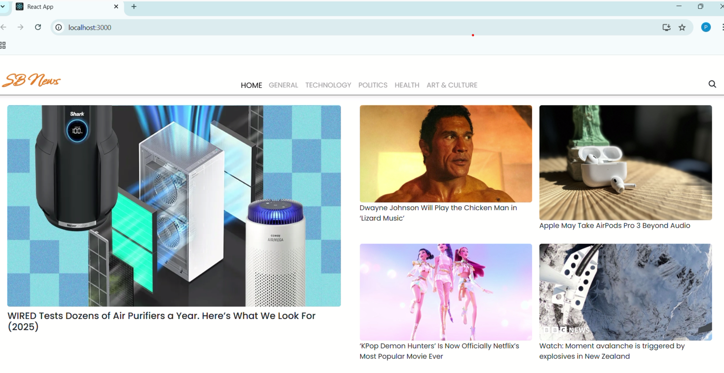

*CODE*

*DEMO LINK:* **